Google Cloud Platform offers a suite of networking services that can help you manage and build complex network architectures, reduce network latency, and simplify network administration. Google Cloud network service provides a global, software-defined network with services for connecting, securing, and managing applications across hybrid/multicloud environments, featuring Virtual Private Clouds (VPCs), Load Balancing, Cloud DNS, CDN, Firewalls, and advanced features like Cross-Cloud Network for unified management, leveraging Google's planet-scale infrastructure for performance, security, and cost optimization through tiers like Premium and Standard.
Google Cloud Networking which is used to connect the different resources available in the cloud together to the internet following are the some of networking services offered by the GCP(Google Cloud Networking).
- Virtual Private Cloud (VPC).
- Subnets.
- Firewall rules.
- Load balancers.
- VPNs

Virtual Private Cloud (VPC) Network:
A Virtual Private Cloud (VPC) network is a virtual version of a physical network that is implemented inside of Google's production network by using Andromeda. A virtual private cloud (VPC) is a secure, isolated private cloud hosted within a public cloud. Virtual Private Cloud, is a logically isolated section within a public cloud (like AWS, Azure, Google Cloud) where you can launch resources in a virtual network you define, giving you private, customizable, and secure control over your IP address range, subnets, gateways, and routing, much like your own private data center but leveraging the public cloud's scalability. Think of it as your own reserved area in a shared public space, allowing you to host applications, store data, and run code securely, isolated from other users.
Virtual Private Cloud (VPC) provides networking functionality to Compute Engine virtual machine (VM) instances, Google Kubernetes Engine (GKE) clusters, and serverless workloads. VPC provides networking for your cloud-based resources and services that is global, scalable, and flexible.
You can think of a VPC network the same way you'd think of a physical network, except that it is virtualized within Google Cloud. A VPC network is a global resource that consists of a list of regional virtual subnetworks (subnets) in data centers, all connected by a global wide area network. VPC networks are logically isolated from each other in Google Cloud.
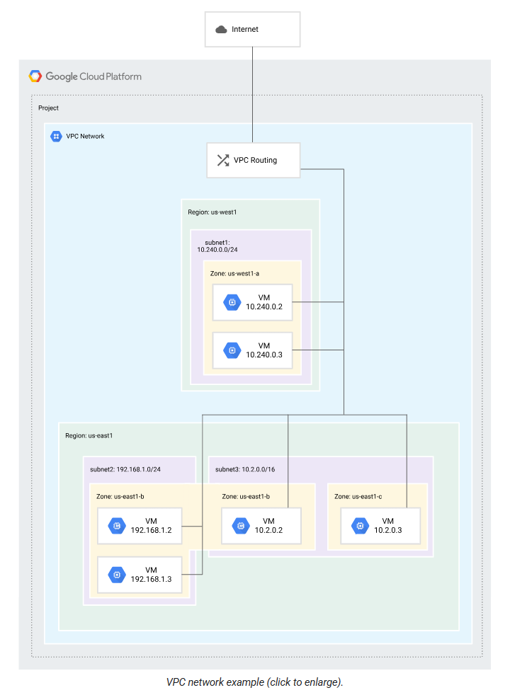

A VPC network does the following:
- Provides connectivity for your Compute Engine virtual machine (VM) instances.
- Offers native internal passthrough Network Load Balancers and proxy systems for internal Application Load Balancers.
- Connects to on-premises networks by using Cloud VPN tunnels and VLAN attachments for Cloud Interconnect.
- Distributes traffic from Google Cloud external load balancers to backends.
Projects can contain multiple VPC networks. Unless you create an organizational policy that prohibits it, new projects start with a default network (an auto mode VPC network) that has one subnetwork (subnet) in each region.
Q: How is GCP VPC different from AWS VPC?
Answer:
- GCP VPC is global; AWS VPC is regional
- Subnets in GCP is regional and subnet in AWS is zonal
- No need for VPC peering for cross-region traffic in GCP
Scope: Regional vs. Zonal
Feature | AWS VPC | GCP VPC
VPC scope | Regional | Global
Subnet scope | Zonal (each subnet in one AZ) | Regional (subnet spans all zones in a region)
- AWS: VPC is regional, but subnets are tied to individual Availability Zones. You must create separate subnets in different AZs for high availability.
- GCP: VPC is global. Subnets are regional, automatically available in all zones within that region. You don’t need to manually create subnets per zone.

In a subnet, a gateway is basically the “door” that lets devices inside the subnet communicate with other subnets or the internet.
A gateway is a network device (often a router) that forwards traffic from the subnet to destinations outside that subnet.
In cloud environments like AWS or GCP, the gateway is usually automatically provided when you create a subnet:

Key Features:
VPC Network: VPC can automatically set up your virtual topology, configuring prefix ranges for your subnets and network policies, or you can configure your own. You can also expand CIDR ranges without downtime.

VPC Flow logs: VPC Flow Logs capture information about the IP traffic going to and from network interfaces on Compute Engine. These VPC flow logs help with network monitoring, forensics, real-time security analysis, and expense optimization. VPC Flow Logs are updated every five seconds, providing immediate visibility, and can be quickly and easily visualized with Flow Analyzer.
Bring your own Ips: Bring your own IP addresses to Google’s network across all regions to minimize downtime during migration and reduce your networking infrastructure cost. After you bring your own IPs, Google Cloud will advertise them globally to all peers. Your prefixes can be broken into blocks as small as 16 addresses (/28), creating more flexibility with your resources.

VPC Peering: Configure private communication across the same or different organizations without bandwidth bottlenecks or single points of failure.

Firewall: Segment your networks with a globally distributed firewall to restrict access to instances. VPC Firewall Rules Logging lets you audit, verify, and analyze the effects of your firewall rules. It logs firewall access and denies events with the same responsiveness of VPC flow logs.

Routes: Forward traffic from one instance to another instance within the same network, even across subnets, without requiring external IP addresses.

Shared VPC: Configure a VPC network to be shared across several projects in your organization. Connectivity routes and firewalls associated are managed centrally. Your developers have their own projects with separate billing and quota, while they simply connect to a shared private network, where they can communicate.

Packet mirroring: Troubleshoot your existing VPCs by collecting and inspecting network traffic at scale, providing intrusion detection, application performance monitoring, and compliance controls with Packet Mirroring.

VPN: Securely connect your existing network to a VPC network over IPsec.

Private access: Get private access to Google services, such as storage, big data, analytics, or machine learning, without having to give your service a public IP address. Configure your application’s front end to receive internet requests and shield your backend services from public endpoints, all while being able to access Google Cloud services.

VPC service control: Mitigate data exfiltration risks by enforcing a security perimeter to isolate resources of multi-tenant Google Cloud services. Configure private communications between cloud resources from VPC networks spanning cloud and on-premise deployments. Keep sensitive data private and take advantage of the fully managed storage and data processing capabilities.

Subnet:
When a bigger network is divided into smaller networks, to maintain security, then that is known as Subnetting. So, maintenance is easier for smaller networks. For example, if we consider a class A address, the possible number of hosts is 224 for each network, it is obvious that it is difficult to maintain such a huge number of hosts, but it would be quite easier to maintain if we divide the network into small parts. Subnetting is the process of dividing a large network into smaller networks called subnets. Each subnet provides its own space for devices to communicate, improving network performance, security, and management.
Virtual Private Cloud (VPC) networks are global resources. Each VPC network consists of one or more IP address ranges called subnets. Subnets are regional resources and have IP address ranges associated with them. In Google Cloud, the terms subnet and subnetwork are synonymous.
A network must have at least one subnet before you can use it. Auto mode VPC networks create subnets in each region automatically. Custom mode VPC networks start with no subnets, giving you full control over subnet creation. You can create more than one subnet per region.
When you create a resource in Google Cloud, you choose a network and subnet. For resources other than instance templates, you also select a zone or a region. Selecting a zone implicitly selects its parent region. Because subnets are regional objects, the region that you select for a resource determines the subnets that it can use

Types of subnet:
VPC networks support subnets with the following stack types. A single VPC network can contain any combination of these subnets.
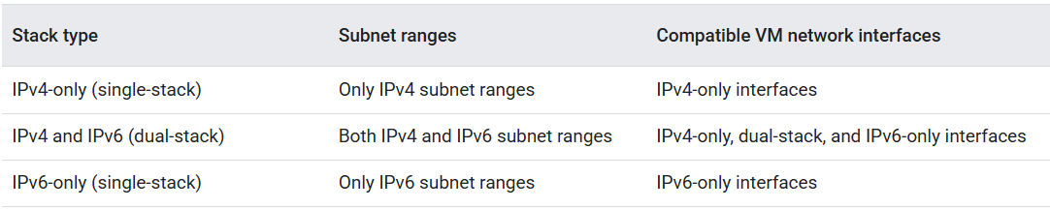

Purposes of subnets:
Subnets can be used for different purposes:
- Regular subnets: This is the default subnet type. Regular subnets are created by users or automatically created in auto mode VPC networks to be used with VM instances. Regular subnets have a purpose of PRIVATE in the gcloud CLI or API. The purpose is None in the Google Cloud console.
- Private Service Connect subnets: A subnet to use to publish a managed service by using Private Service Connect.
- Proxy-only subnets: A proxy-only subnet to use with regional Envoy-based load balancers.
- Private NAT subnets: A subnet that is reserved for use as the source range for Private NAT.
- Peer migration subnets: A subnet to use to migrate a Shared VPC service to Private Service Connect.
- Hybrid subnets: A subnet that logically extends to an on-premises or source network, letting you migrate workloads to Google Cloud without needing to change IP addresses.

Firewall rules
Each VPC network implements a distributed virtual firewall that you can configure. Firewall rules let you control which packets are allowed to travel to which destinations. Every VPC network has two implied firewall rules that block all incoming connections and allow all outgoing connections.
The default network has additional firewall rules, including the default-allow-internal rule, which permit communication among instances in the network.
VPC firewall rules let you allow or deny connections to or from virtual machine (VM) instances in your VPC network. Enabled VPC firewall rules are always enforced, protecting your instances regardless of their configuration and operating system, even if they have not started up.
Every VPC network functions as a distributed firewall. While firewall rules are defined at the network level, connections are allowed or denied on a per-instance basis. You can think of the VPC firewall rules as existing not only between your instances and other networks, but also between individual instances within the same network.

Routes:
Routes tell VM instances and the VPC network how to send traffic from an instance to a destination, either inside the network or outside of Google Cloud. Each VPC network comes with some system-generated routes to route traffic among its subnets and send traffic from eligible instances to the internet.
You can create custom static routes to direct some packets to specific destinations.
Cloud Router enables you to dynamically exchange routes between your Virtual Private Cloud (VPC) and peer network by using Border Gateway Protocol (BGP). Google Cloud routes define the paths that network traffic takes from a virtual machine (VM) instance to other destinations. These destinations can be inside your Google Cloud Virtual Private Cloud (VPC) network (for example, in another VM) or outside it.
In a VPC network, a route consists of a single destination prefix in CIDR format and a single next hop. When an instance in a VPC network sends a packet, Google Cloud delivers the packet to the route's next hop if the packet's destination address is within the route's destination range.

Forwarding rules
While routes govern traffic leaving an instance, forwarding rules direct traffic to a Google Cloud resource in a VPC network based on IP address, protocol, and port.
Some forwarding rules direct traffic from outside of Google Cloud to a destination in the network; others direct traffic from inside the network. Destinations for forwarding rules are target instances, load balancer targets (backend services, target proxies, and target pools), and Classic VPN gateways.
A forwarding rule specifies how to route network traffic to the backend services of a load balancer. A forwarding rule includes an IP address, an IP protocol, and one or more ports on which the load balancer accepts traffic. Some Google Cloud load balancers limit you to a predefined set of ports, and others let you specify arbitrary ports.
A forwarding rule and its corresponding IP address represent the frontend configuration of a Google Cloud load balancer.
Depending on the load balancer type, the following is true:
- Forwarding rules specify either a backend service, target proxy, or target pool.
- Forwarding rules and their IP addresses are either internal or external.
- Forwarding rules are either global or regional, depending on the load balancer and its network tier.

VPC sharing and peering
Google Cloud provides the following configurations for sharing VPC networks across projects and connecting VPC networks to each other. To access resources across multiple VPC networks and Google Cloud projects, you must also configure Shared VPC or VPC Network Peering.

Shared VPC (shared vpc share one VPC network across multiple projects)
You can share a VPC network from one project (called a host project) to other projects in your Google Cloud organization. You can grant access to entire Shared VPC networks or select subnets therein by using specific IAM permissions. This lets you provide centralized control over a common network while maintaining organizational flexibility. Shared VPC is especially useful in large organizations.
Shared VPC allows an organization to connect resources from multiple projects to a common Virtual Private Cloud (VPC) network so that they can communicate with each other securely and efficiently by using internal IP addresses from that network.
When you use Shared VPC, you designate a project as a host project and attach one or more other service projects to it. The VPC networks in the host project are called Shared VPC networks. Eligible resources from service projects can use subnets in the Shared VPC network.

VPC Network Peering (VPC network peering Connect two separate VPC networks)
VPC Network Peering lets you build software as a service (SaaS) ecosystems in Google Cloud, making services available privately across different VPC networks, whether the networks are in the same project, different projects, or projects in different organizations.
With VPC Network Peering, all communication happens by using internal IP addresses. Subject to firewall rules, VM instances in each peered network can communicate with one another without using external IP addresses.
Peered networks automatically exchange subnet routes for private IP address ranges. VPC Network Peering lets you configure whether the following types of routes are exchanged:
- Subnet routes for privately re-used public IP ranges
- Custom static and dynamic routes
Network administration for each peered network is unchanged: IAM policies are never exchanged by VPC Network Peering. For example, Network and Security Admins for one VPC network do not automatically get those roles for the peered network.

Google Cloud VPC Network Peering connects two Virtual Private Cloud (VPC) networks so that resources in each network can communicate with each other. Peered VPC networks can be in the same project, different projects of the same organization, or different projects of different organizations.

Cloud VPN:
Cloud VPN lets you connect your VPC network to your physical, on-premises network or another cloud provider by using a secure virtual private network. Cloud VPN securely extends your peer network to Google's network through an IPsec VPN tunnel. Traffic is encrypted and travels between the two networks over the public internet. Cloud VPN is useful for low-volume data connections.

Cloud Interconnect
Cloud Interconnect provides low-latency, high-availability connections that enable you to reliably transfer data between your networks. Cloud Interconnect lets you connect your VPC network to your on-premises network by using a high-speed physical connection.
Cloud Interconnect extends your external network to the Google network through a high-availability, low-latency connection. You can use Dedicated Interconnect to connect directly to Google. Alternatively, you can use Partner Interconnect to connect to Google through a supported service provider. You can use Cross-Cloud Interconnect to connect to your network that's hosted by another cloud service provider.
- Dedicated Interconnect provides direct physical connections between your on-premises network and Google's network. Dedicated Interconnect lets you transfer large amounts of data between networks, which can be more cost-effective than purchasing additional bandwidth over the public internet.
- Partner Interconnect provides connectivity between your on-premises network and your Virtual Private Cloud (VPC) network through a supported service provider. A Partner Interconnect connection is useful if your data center is in a physical location that can't reach a Dedicated Interconnect colocation facility, or your data needs don't warrant an entire 10-Gbps connection.
- Cross-Cloud Interconnect is a product that helps you establish high-bandwidth dedicated connectivity between Google Cloud and another cloud service provider. When you buy Cross-Cloud Interconnect, Google provisions a dedicated physical connection between the Google network and that of another cloud service provider. You can use this connection to peer your Google Virtual Private Cloud (VPC) network with your network that's hosted by a supported cloud service provider.
Cloud interconnect refers to a dedicated connection between your on-premise network and a cloud provider's network. Unlike relying on the public internet, it establishes a private, high-bandwidth connection that bypasses the internet for enhanced performance, security, and reliability.
Think of it as a dedicated, private highway for your information to travel between your own infrastructure and the cloud.
This straight connection facilitates seamless data transfer, allowing businesses to extend their on-premise nets into the cloud environment. It's like building a bridge that eliminates the traffic congestion and security risks associated with internet pathways.

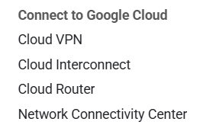

Serverless VPC access:
Serverless VPC Access allows Cloud Functions, Cloud Run (fully managed) services and App Engine standard environment apps to access resources in a VPC network using the internal IP addresses of those resources
Serverless VPC access is a feature that connects serverless environments like Cloud Functions and App Engine to a private Virtual Private Cloud (VPC) network without using the public internet. It works by creating a serverless VPC access connector, which is a resource that handles the internal traffic between the two environments. To use it, you must create a connector in the same region as your serverless service and attach it to a specific VPC network and a custom IP range.
Use Serverless VPC Access to connect directly to your VPC network from serverless environments such as Cloud Run and App Engine. Configuring Serverless VPC Access lets your serverless environment send requests to your VPC network by using internal DNS and internal IP addresses (as defined by RFC 1918 and RFC 6598). The responses to these requests also use your internal network.
There are two main benefits to using Serverless VPC Access:
- Requests sent to your VPC network are never exposed to the internet.
- Communication through Serverless VPC Access can have less latency compared to the internet.
Serverless VPC Access sends internal traffic from your VPC network to your serverless environment only when that traffic is a response to a request that was sent from your serverless environment through the Serverless VPC Access connector. To learn about sending other internal traffic, see Private Google Access.
To access resources across multiple VPC networks and Google Cloud projects, you must also configure Shared VPC or VPC Network Peering.

How it works
Serverless VPC Access is based on a resource called a connector. A connector handles traffic between your serverless environment and your VPC network. When you create a connector in your Google Cloud project, you attach it to a specific VPC network and region. You can then configure your serverless services to use the connector for outbound network traffic.
serverless vpc access connector: Is used to send requests from serverless environments to your vpc network without using the public internet.

IP address ranges
There are two options for setting the IP address range for a connector:
- Subnet: You can specify an existing /28 subnet if there are no resources that already use the subnet.
- CIDR range: You can specify an unused /28 CIDR range. When specifying this range, make sure that it doesn't overlap with any in-use CIDR ranges.
Traffic sent through the connector into your VPC network originates from the subnet or CIDR range that you specify.

Use cases
You can use Serverless VPC Access to access Compute Engine VM instances, Memorystore instances, and any other resources with internal DNS or internal IP address. Some examples are:
- You use Memorystore to store data for a serverless service.
- Your serverless workloads use third-party software that you run on a Compute Engine VM.
- You run a backend service on a Managed Instance Group in Compute Engine and need your serverless environment to communicate with this backend without exposure to the internet.
- Your serverless environment needs to access data from your on-premises database through Cloud VPN.
Example
In this example, a Google Cloud project is running multiple services across the following serverless environments: App Engine, Cloud Run functions, and Cloud Run.
A Serverless VPC Access connector was created and assigned the IP range 10.8.0.0/28. Therefore, the source IP address for any request sent from the connector is in this range.
There are two resources in the VPC network. One of the resources has the internal IP address 10.0.0.4. The other resource has the internal IP address 10.1.0.2, and is in a different region than the Serverless VPC Access connector.
The connector handles sending and receiving both the requests and responses directly from these internal IP addresses. When the connector sends requests to the resource with internal IP address 10.1.0.2, outbound data transfer costs apply because that resource is in a different region.
All requests and responses between the serverless environments and the resources in the VPC network travel internally.
Requests sent to external IP addresses still travel through the internet and don't use the Serverless VPC Access connector.
The following diagram shows this configuration.
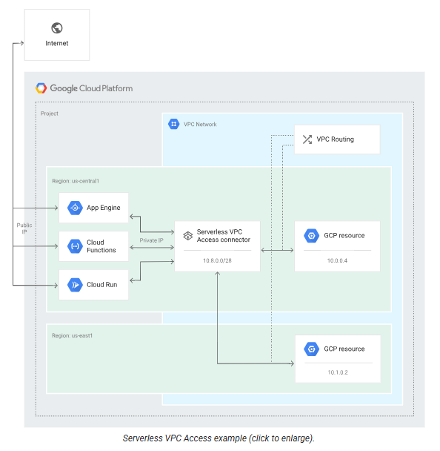
VPN Tunnel:
A VPN tunnel is a secure, encrypted connection between two networks or devices over the internet. It lets data travel privately as if both ends were on the same local network—even though they’re far apart.

Static IP address:
A Static IP address is a permanent network address that doesn't change for a device, unlike a dynamic IP address which can be reassigned. To preserve an IP address in Google Cloud (GCP), you need to reserve a static external or internal IP address in Virtual Private Cloud (VPC) networks. Ephemeral IP addresses, which are assigned by default, will change when an instance is stopped and restarted. Static IPs, on the other hand, remain associated with the instance even after it's stopped and restarted. Static internal IP addresses provide the ability to reserve internal or external IP addresses from the IP address range configured in the subnet and then assign those reserved internal IP addresses to resources as needed. Reserving an internal IP address takes that address out of the dynamic allocation pool and prevents it from being used for automatic allocations. Reserving static internal IP addresses requires specific Identity and Access Management (IAM) permissions so that only authorized users can reserve a static internal IP address.
Static internal IP addresses provide the ability to reserve internal IP addresses from the IP address range configured in the subnet and then assign those reserved internal IP addresses to resources as needed. Reserving an internal IP address takes that address out of the dynamic allocation pool and prevents it from being used for automatic allocations. Reserving static internal IP addresses requires specific Identity and Access Management (IAM) permissions so that only authorized users can reserve a static internal IP address.
Cloud VPN or Cloud Interconnect (dedicated vs partner interconnect)

Master Prompt: GCP Cloud Networking Interview Preparation
You are a Senior Google Cloud Platform (GCP) Cloud Network Architect and Interviewer.

I am preparing for GCP Cloud Networking interviews (Associate / Professional Cloud Network Engineer / DevOps / SRE roles).

Generate a COMPLETE and EXHAUSTIVE list of interview questions with DETAILED, BEST-PRACTICE answers on Google Cloud Networking.

Cover the following in depth:
1. GCP Networking fundamentals (global VPC, subnets, CIDR, routes)
2. VPC architecture (auto vs custom mode, shared VPC, VPC peering)
3. IP addressing (internal/external IPs, alias IPs, IPv4 vs IPv6)
4. Firewall rules (hierarchy, priority, service accounts vs tags)
5. Routing (system routes, custom routes, dynamic routing, ECMP)
6. Load balancing (HTTP(S), TCP/UDP, Internal LB, global vs regional)
7. Hybrid connectivity (Cloud VPN, HA VPN, Cloud Interconnect, Partner Interconnect)
8. Private access (Private Google Access, Private Service Connect)
9. DNS in GCP (Cloud DNS, private zones, forwarding, split-horizon DNS)
10. NAT and internet access (Cloud NAT, egress patterns)
11. Network security (VPC Service Controls, Cloud Armor, IAP)
12. Connectivity to on-prem and multi-cloud architectures
13. Network monitoring & troubleshooting (VPC Flow Logs, Packet Mirroring)
14. IAM & networking relationship
15. Cost optimization and design best practices
16. Real-world architecture scenarios and troubleshooting cases
17. Common interview traps and misconceptions
18. Comparison questions (GCP vs AWS networking)
19. Behavioral + scenario-based questions
20. Hands-on CLI and Terraform-based networking questions

For EACH topic:
- Beginner, Intermediate, and Advanced interview questions
- Clear, concise, and technically accurate answers
- Diagrams explained in words (no images)
- Real-world production examples
- Command examples (gcloud, Terraform) where relevant
- Common mistakes interviewers expect candidates to avoid

Structure the output as:
- Topic heading
- Questions
- Best possible answers
- Key takeaways
- Interview tips

Assume the interviewer is a Google Cloud SME.
Do NOT skip any important networking concept.

